Configuring Windows Server as a Domain Controller
- The objective is to setup an Active Directory with a windows server as the Domain Controller and a Windows 10 Machine who will be our “User”.
- I’ll be setting this server up as the “VICTIMNETWORK” discussed in earlier documentations.
- Machine Configuration: 60GB Disk, 2GB Memory, 2 Processors, and Network Adpater set to Vmnet2 “VICTIMNETWORK”
- I’m going to select custom install
- Click the following: New → Apply → OK → Next
- Setup the Administrator’s password
- Once I get to the desktop. I want to rename the Domain Controller.
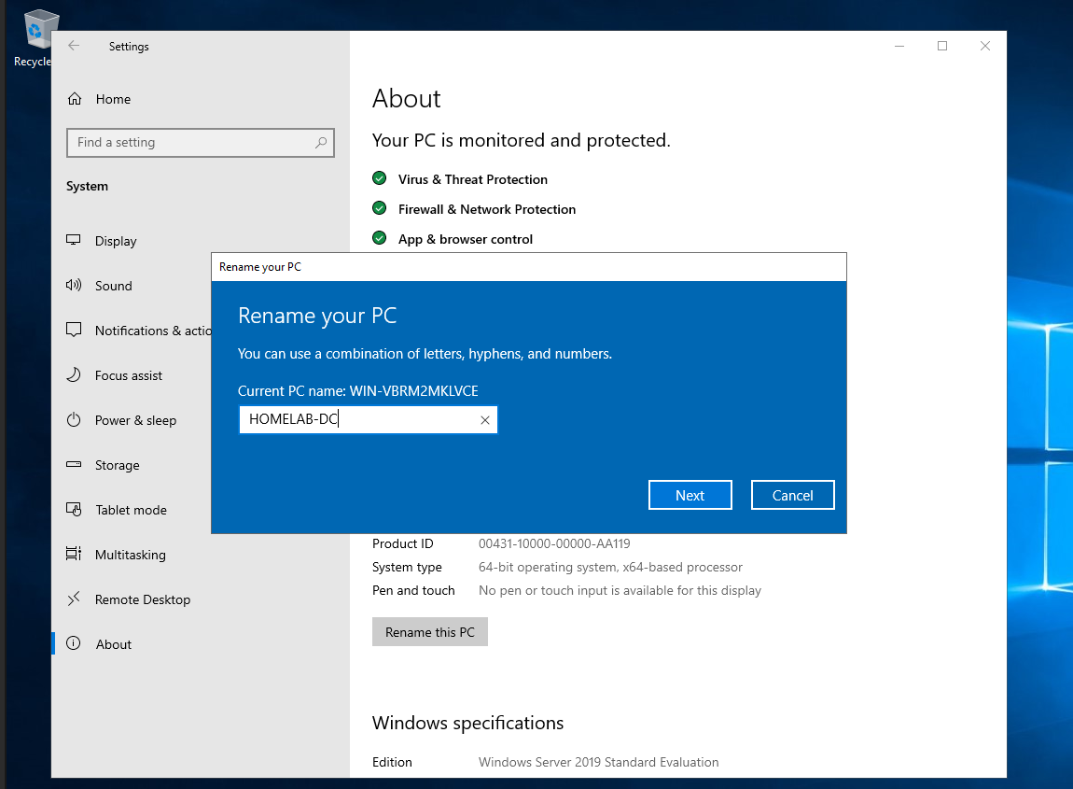
- I renamed mine to HOMELAB-DC
- After the reboot, on the Server Manager Dashboard, Click Manage >> Add Roles and Features
- Keep clicking NEXT until I see the Server Roles Menu
- Check “Active Directory Domain Services” → Add Features → Install
- Once it finished installing. Click the flag and click “Promote this server to a domain controller”
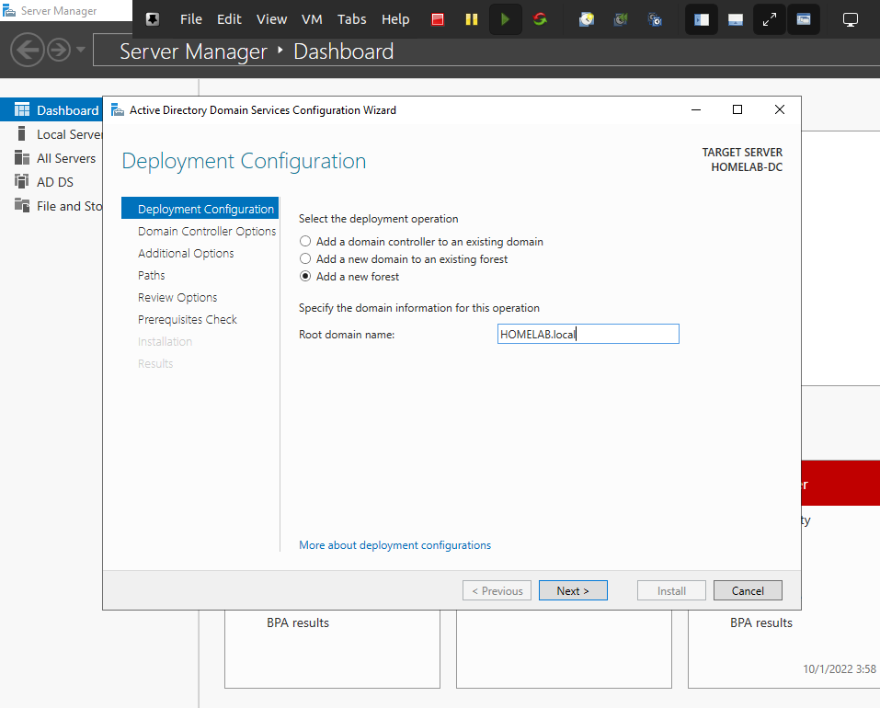
- I will be adding a new forest and naming it HOMELAB.local
- Once it reboots head back into Mange → Add Roles & Features
- Select Active Directory Certificate Services → Add Features
- 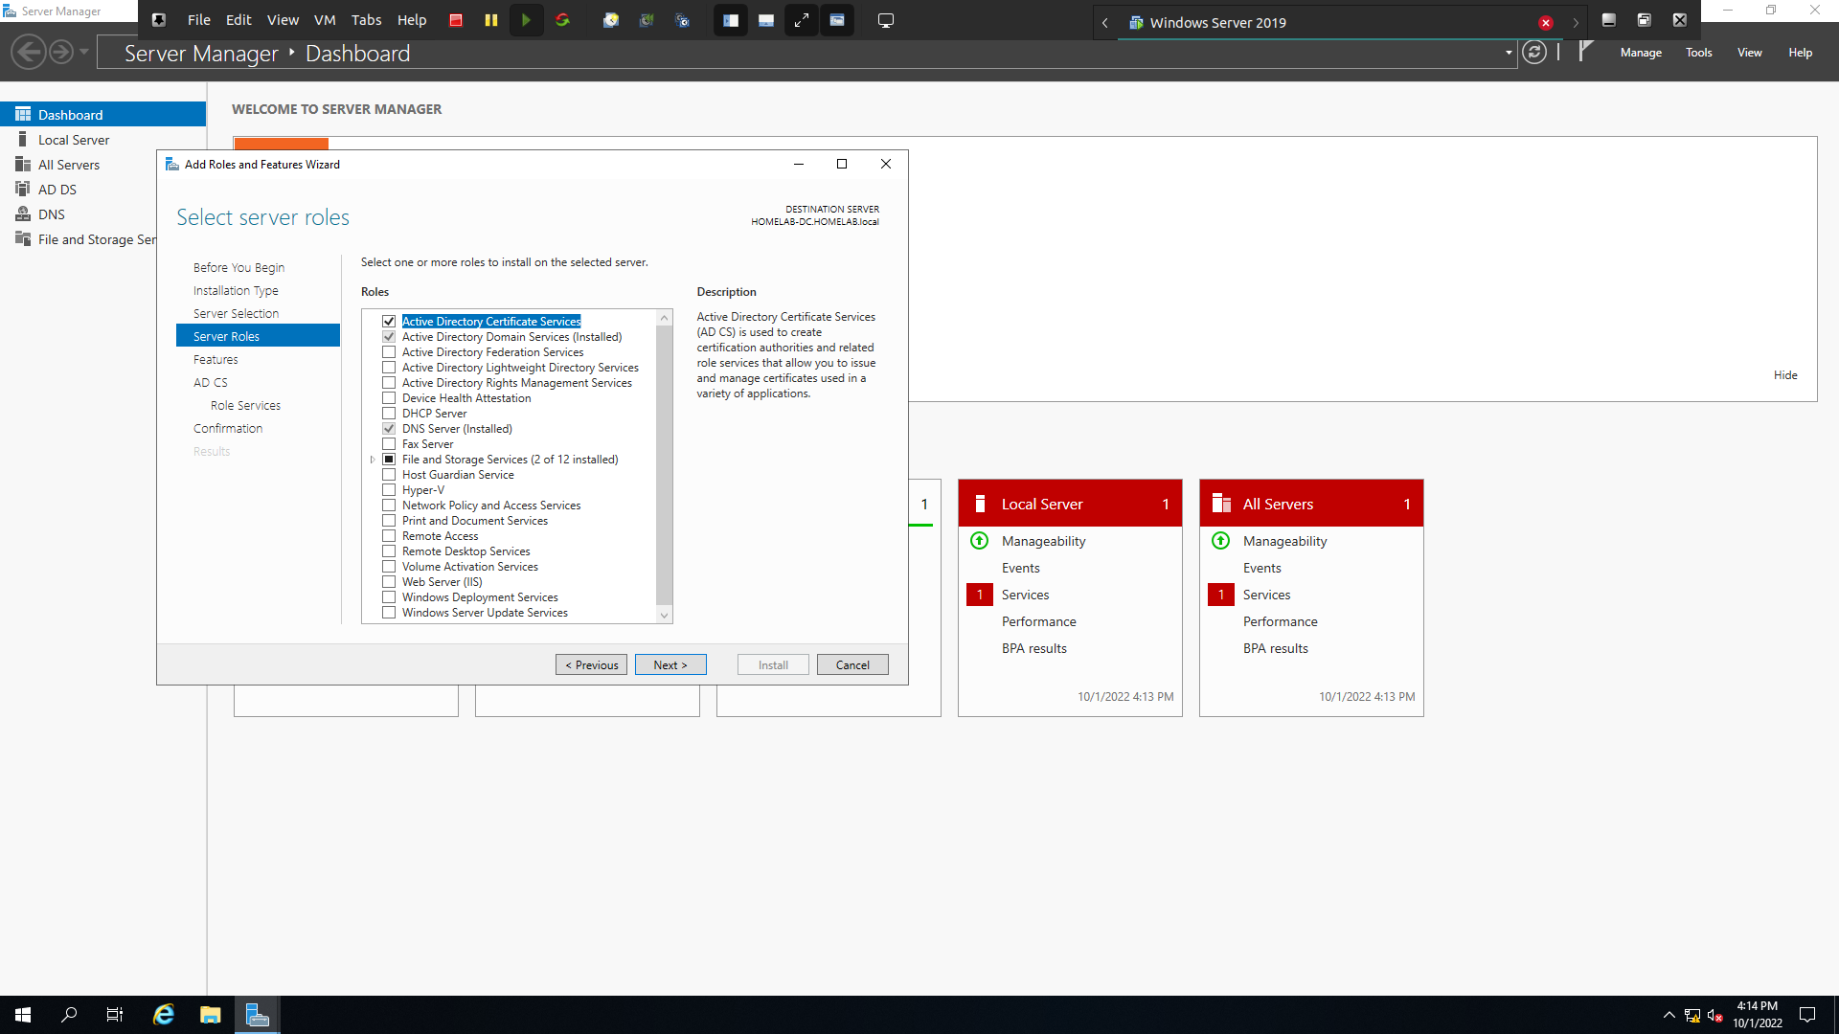
- Click Next till you get to the “Confirmation” menu.
- Make sure to check off “Restart the destination server automatically if required“.
- After Installation, click close.
- Back to the flag and click “Configure Active Directory Certificate Services on the destination server“.
- Click next on Credentials and check “Certification Authority”.
- I set the validity period for 99 years (No reason).
- Keep clicking Next until Confirmation menu. Select Configure.
- In order for all the changes to take effect I need to manually reset the machine.
- Once the system boots back up. Ill add my User.
- Back at the Server Manager Select Tools → Active Directory Users and Computers
- Select your Domain Name (HOMELAB.local) → Users, Right Click & Select New → User
- 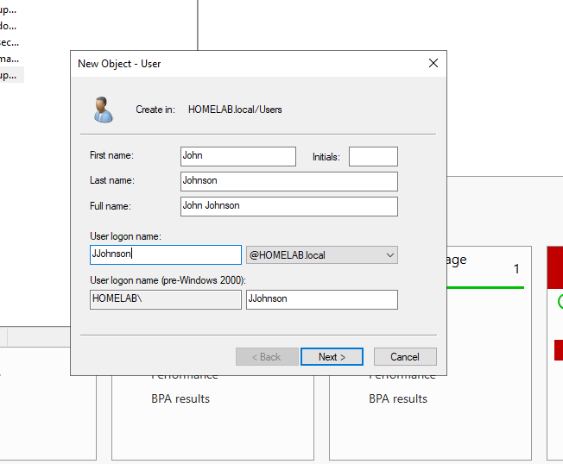
- Set Password. Make sure to check that it never expires (Normally I wouldn't recommend this, but for the sake of the lab its ok!)
- Since I am using pfsense as the main firewall I will be disabling Windows Defender.
- Search for “Windows Defender Firewall” → Turn Windows Defender Firewall on or off.
- 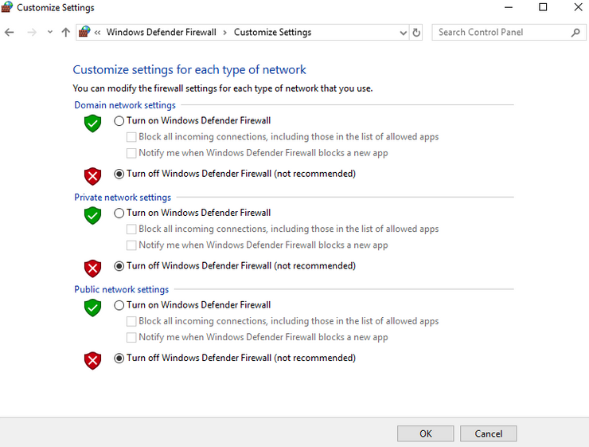
- Now I can use pfsense as the default gateway for the Domain Controller
- Select Control Panel → Network and Internet → Network Connections
- Enter the following configuration:
- 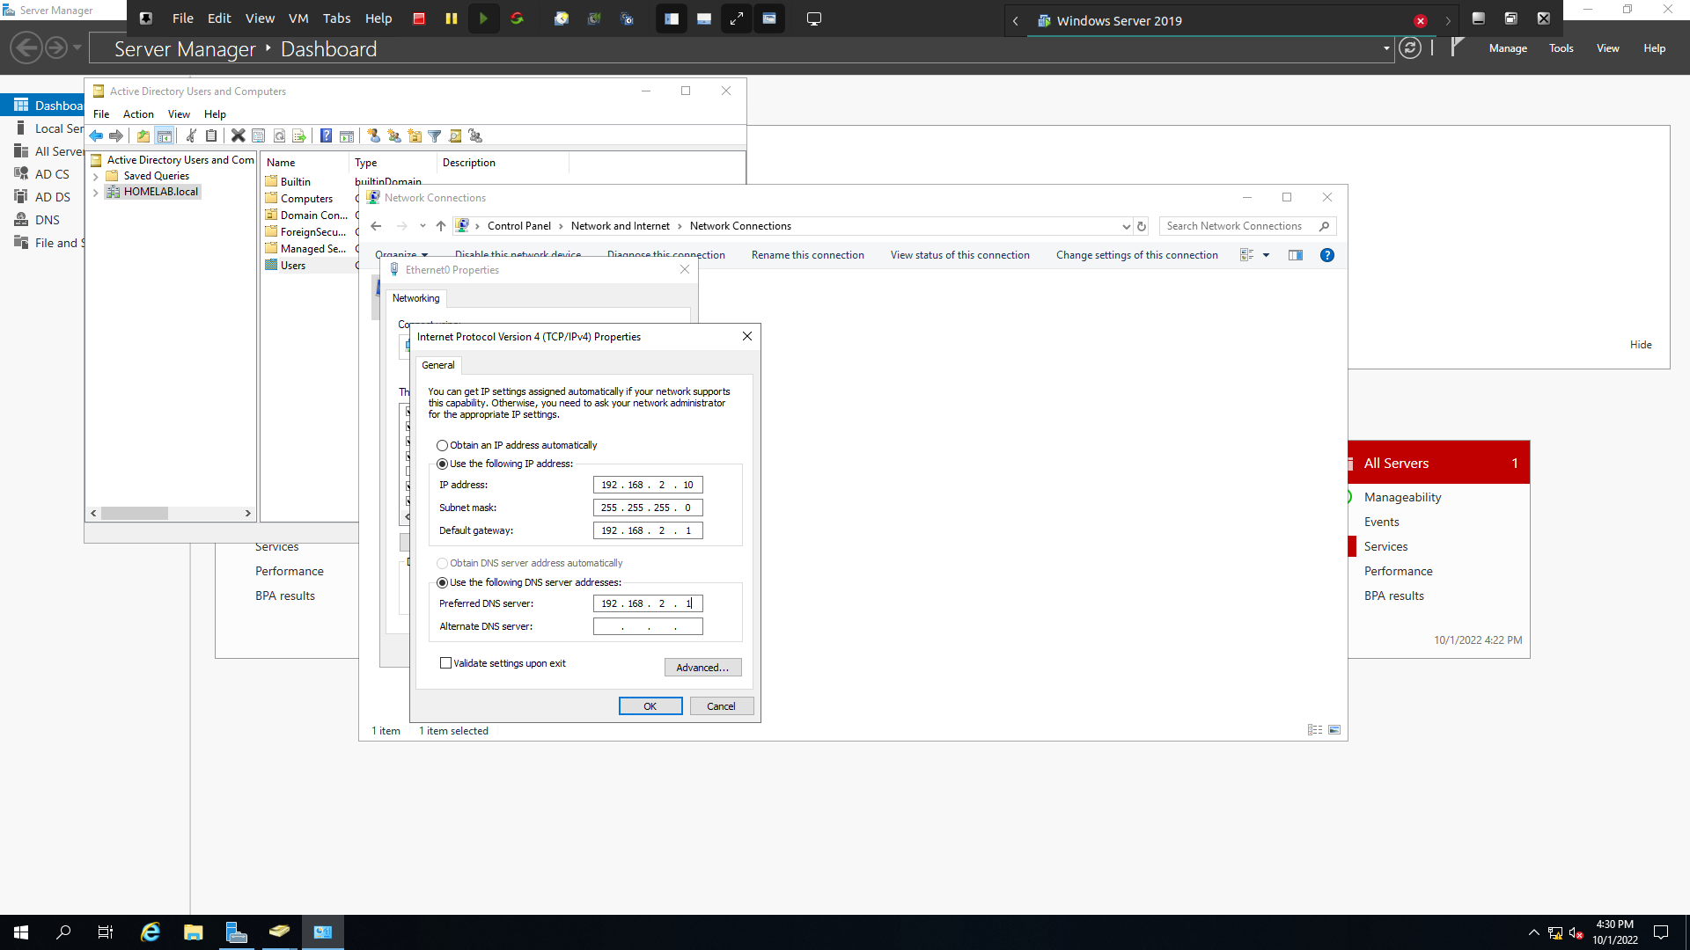

Now I will Configure a Windows 10 Desktop and Add the user to the AD domain
- I will be using a Windows 10 Evaluation ISO
- VM Configuration: default
- Make sure to name it the same as the user we created in the DC (JJOHNSON)
- Make sure to set the network adapter as Vmnet3 (VICTIMNETWORK)
- After the installation process has finished. I want to rename the PC. (JJOHNSON)
- Search “pc name” and change the PC Name according to the designated users

ADDING THE PC TO THE DOMAIN
- Navigate to the Network Adapter Settings
- Right-click on Ethernet0 → select properties → Select IPv4
- Add an IP Address (192.168.2.31) & Use 192.168.2.1 as the default gateway
- Use 192.168.2.10 (VICTIMNETWORK) as the DNS Server
- 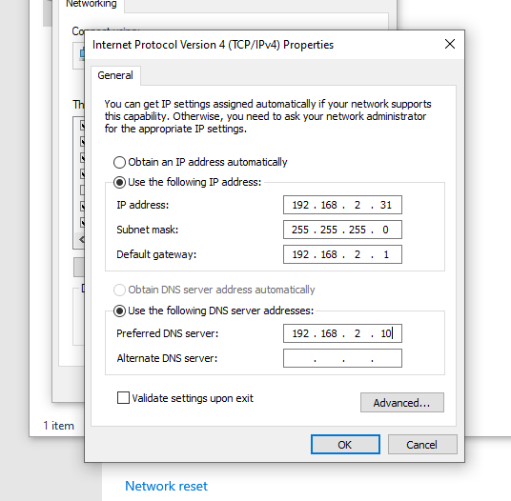
- Lets connect this machine to the AD Domain
- Search “domain” → select Access work or school → Select Connect → Join this device to local Active Directory Domain
- Enter your domain name.local (HOMELAB.local)
- Enter the Username: Administrator and the password of your DC
- 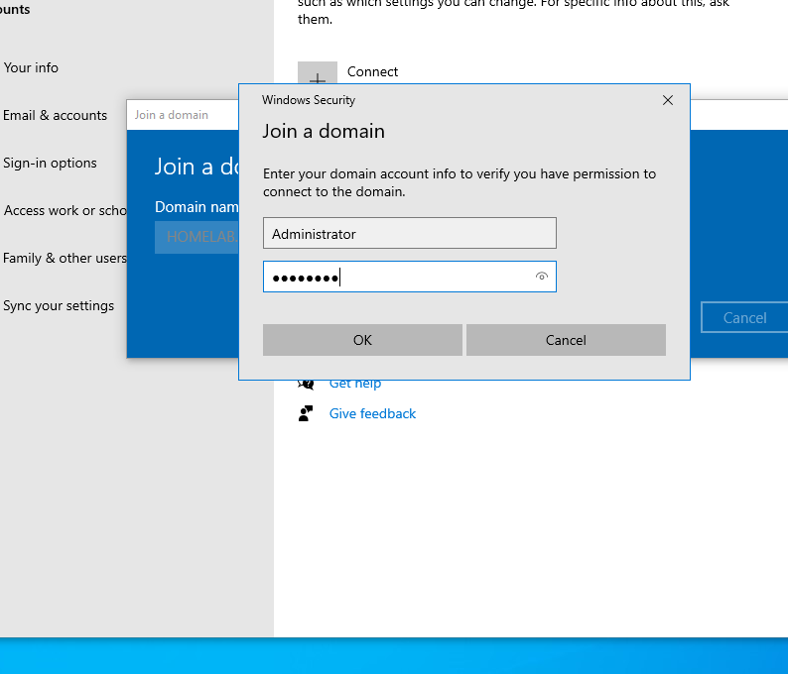
- Select Skip → RESTART
- Now going back to the DC interface I can see that user’s machine has been added.

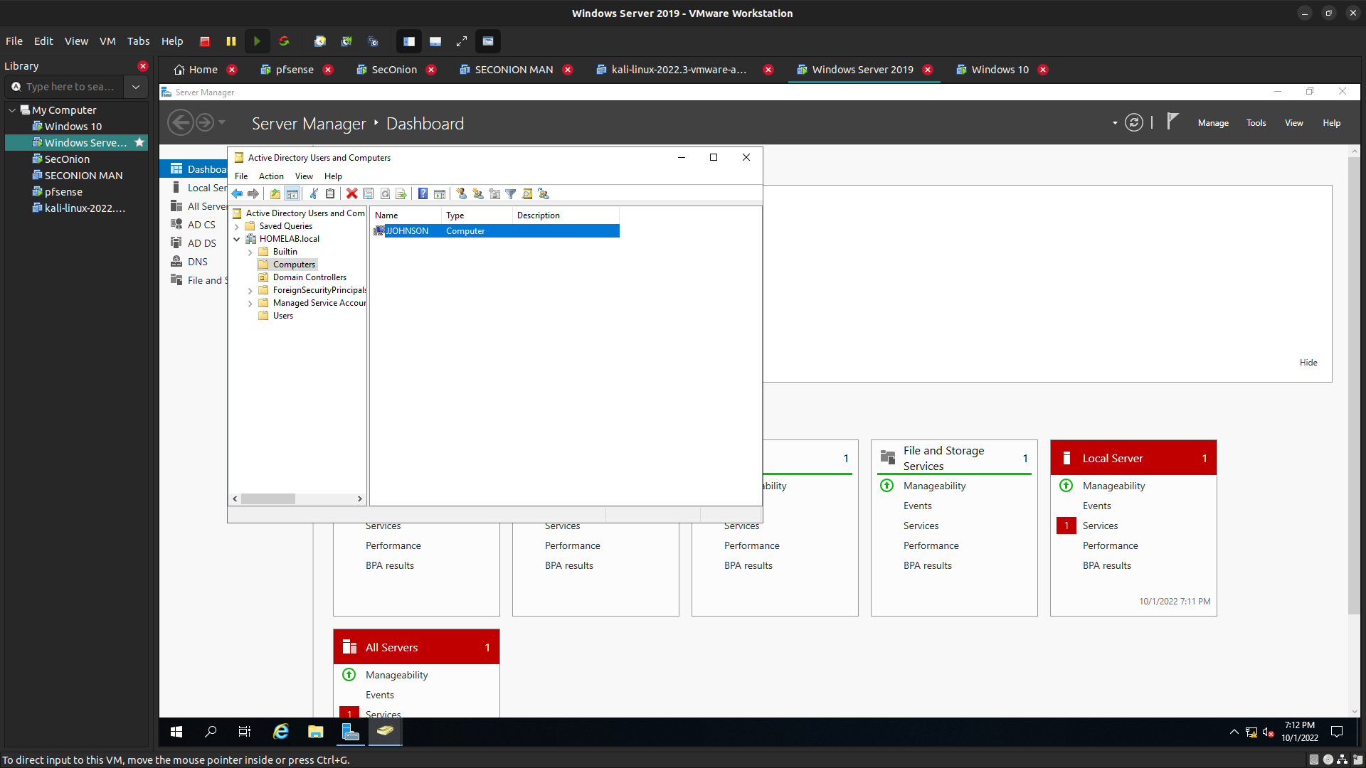

That concludes the Domain Controller configuration. I enjoyed this part of the lab! I got to setup my own Active Directory and add users to the AD domain, as I would in an enterprise environment.

